

**PROJECT REPORT**

**DEPARTMENT OF ELECTRICAL, ELECTRONIC AND COMMUNICATION ENGINEERING**

**COURSE CODE: EECE-106**

**PROJECT RRPORT OF GROUP 2**

**PROJECT NAME: Arduino Based Car parking System**

**By: SECTION- B**

|  |  |
| --- | --- |
| **Name** | **ID** |
| Osama Ahmed Ibrahim | 202316126 |
| MD. Jiman | 202316101 |
| Imam Hasan | 202316081 |
| Md Humaun Kabir Nahid | 202216040 |

Level-1, Term-2

Electrical Electronic and Communication Engineering

Military Institute of Science and Technology.

**Table Of Contents:**

|  |  |
| --- | --- |
| Title | Page Number |
| i. Abstract | 3 |
| ii. Introduction | 3 |
| iii. Literature Review | 4 |
| iv. Methodology | 12 |
| v. Analysis | 12 |
| vi. Result and Findings | 13 |
| vii. Conclusion | 15 |
| viii. References | 15 |

**Abstract**

The Arduino-based car parking system is a smart solution designed to efficiently manage parking spaces. Using ultrasonic sensors, it detects the availability of parking spots and relays real-time information to a central control unit. This system aids drivers in locating vacant spaces, reducing congestion, and optimizing parking utilization, contributing to a more streamlined and organized parking experience.

**Introduction**

It is An Arduino-based car parking system that intelligently manages both ingoing and outgoing vehicles. Utilizing sensors, the system accurately detects free spaces, guiding incoming cars for efficient parking. Additionally, it facilitates gate operations for outgoing vehicles, ensuring seamless exit processes and enhancing overall parking management.

**Literature review:**

This literature review explores the various applications of Arduino in car parking systems, focusing on the following aspects:

* Functionalities: Different functionalities and features offered by Arduino-based car parking systems.
* Sensor technologies: Various sensors used to detect and track vehicles and parking space availability.
* Communication protocols: Methods used for data exchange between sensors, Arduino, and external devices.
* Advantages and limitations: Benefits and drawbacks of using Arduino for car parking systems.

Functionalities

Arduino-based car parking systems can offer a wide range of functionalities, including:

* Parking space detection: Using ultrasonic sensors, infrared sensors, or weight sensors to detect occupied and vacant parking spaces.
* Real-time information display: Displaying the number of available parking spaces on LED screens or mobile apps.
* Parking guidance system: Guiding drivers to vacant parking spaces using LED arrows or audio instructions.
* Automated parking lot entry and exit: Controlling gates and barriers based on vehicle authorization or payment status.
* Reservation system: Allowing drivers to reserve parking spaces in advance through mobile apps or online platforms.
* Security features: Monitoring parking areas for unauthorized vehicles or potential security threats.

**Objectives and goals**

* Time Efficient Solution
* Reduce Parking Stress
* Reduce Search Traffic on Parking Garage
* User-friendly Interface

**Circuit Diagram:**

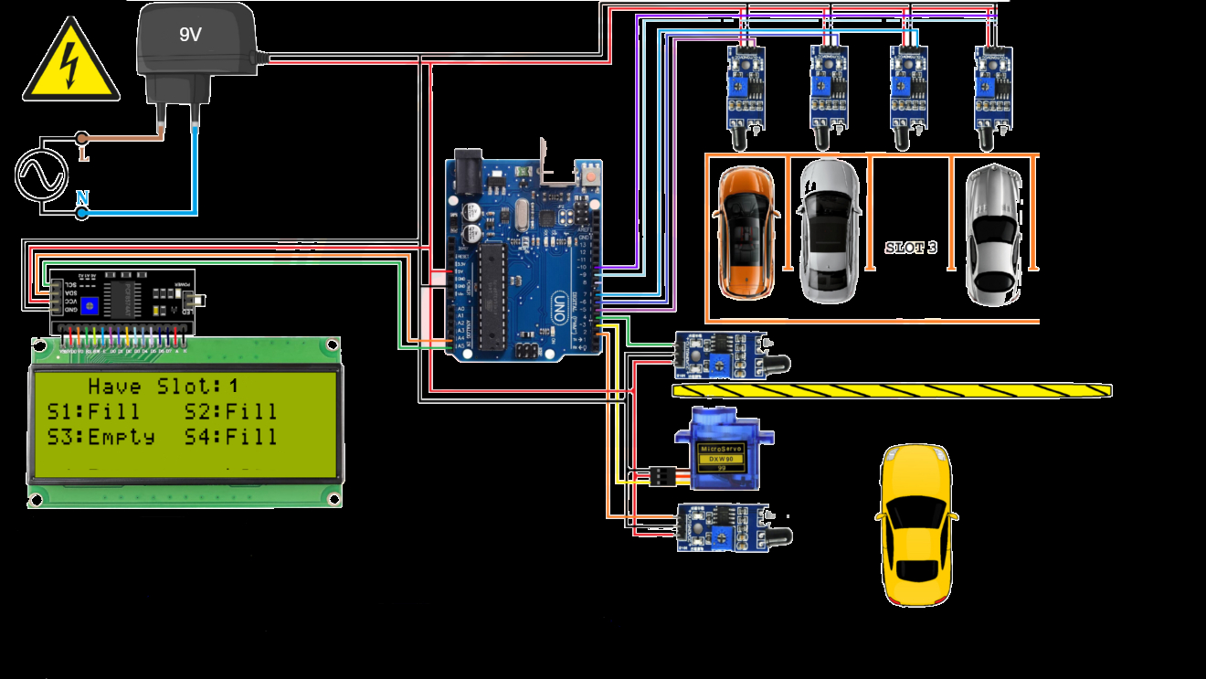

**Arduino Code**

/////////////////////////////Osama Ahmed Ibrahim////////////////////////////////

#include <Wire.h>

#include <LiquidCrystal_I2C.h>   ///// sda = A4 , scl = A5

LiquidCrystal_I2C lcd(0x27, 16, 2);

#include<Servo.h>

Servo gate;

int I;

///////////////

int s1 = 8; // sensor 1

int s2 = 9; // sensor 2

int s3 = 10; // sensor 3

int s4 = 11; // sensor 4

int snin = 4; // in sensor

int snout = 5; // out sensor

//////////////

int v1;

int v2;

int v3;

int v4;

int vin;

int vout;

void setup() {

  lcd.begin();

  lcd.backlight();

  pinMode(s1,INPUT);

  pinMode(s2,INPUT);

  pinMode(s3,INPUT);

  pinMode(s4,INPUT);

  pinMode(snin,INPUT);

  pinMode(snout,INPUT);

  gate.attach(3);

  gate.write(90);

}

void loop() {

 lcd.setCursor(0,0);

 lcd.print(“S1:”);

 lcd.setCursor(9,0);

 lcd.print(“S2:”);

 lcd.setCursor(0,1);

 lcd.print(“S3:”);

 lcd.setCursor(9,1);

 lcd.print(“S4:”);

 v1 = digitalRead(s1);

 v2 = digitalRead(s2);

 v3 = digitalRead(s3);

 v4 = digitalRead(s4);

 vin = digitalRead(snin);

 vout = digitalRead(snout);

 ///////////////////////////////

 if(v1==0)

 {

  lcd.setCursor(4,0);

  lcd.print(“F”);

  }

 else

 {

  lcd.setCursor(4,0);

  lcd.print(“E”);

  }

////////////////////////

if(v2==0)

 {

  lcd.setCursor(13,0);

  lcd.print(“F”);

  }

 else

 {

  lcd.setCursor(13,0);

  lcd.print(“E”);

  }

////////////////////////

if(v3==0)

 {

  lcd.setCursor(4,1);

  lcd.print(“F”);

  }

 else

 {

  lcd.setCursor(4,1);

  lcd.print(“E”);

  }

//////////////////////////

if(v4==0)

 {

  lcd.setCursor(13,1);

  lcd.print(“F”);

  }

 else

 {

  lcd.setCursor(13,1);

  lcd.print(“E”);

  }

//////////////////////////

if (v1 == 0 && v2 == 0 && v3 == 0 && v4 == 0 && vin == 0)

{

  lcd.clear();

  lcd.setCursor(6,0);

  lcd.print(“Full”);

  delay(200);

  lcd.clear();

  lcd.setCursor(6,0);

  lcd.print(“Full”);

  delay(200);

  lcd.clear();

  lcd.setCursor(6,0);

  lcd.print(“Full”);

  lcd.clear();

  gate.write(90);

}

else{

    if (vin == 0)

{

  for (I = 90; I >= 0; I -= 1)

  {gate.write(i);

  delay(8);}

  delay(3000);

  for (I = 0; I <= 90; I += 1)

  {gate.write(i);

  delay(15);}

}

if (vout == 0)

{

  for (I = 90; I >= 0; I -= 1)

  {gate.write(i);

  delay(8);}

  delay(3000);

  for (I = 0; I <= 90; I += 1)

  {gate.write(i);

  delay(15);}

}

  }

}

**Lcd display 16*2 with i2c**

**module**

**Power**

**IR Sensor**

**Servo Motor**

**FLOW CHART**

**Arduino UNO**

**IR Sensor**

**Slot 1**

**Slot 2**

**Slot 3**

**Slot**

**4**

**METHODOLOGY**

This system is capable of finding the empty slots that are available for parking automatically. If the slot is empty in the **automated car parking** the new vehicles are allowed to enter the parking else the entrance is blocked by using the servo barrier in case no empty slot is found by the system. The drivers can see the status for the availability of the free space outside the parking on a LCD. If slot is empty driver can see “E” on the display which means EMPTY. If slot is full driver can see “F” on the display which means FULL.

**Analysis**

Arduino-based car parking systems have emerged as a popular and cost-effective solution to address the growing challenges of urban parking management. By leveraging the affordability, ease of use, and flexibility of Arduino microcontrollers, these systems offer a range of functionalities to optimize parking space utilization and enhance driver experience.

**Parking space detection:** Employing ultrasonic sensors, infrared sensors, or weight sensors to identify occupied and vacant spaces.

**Real-time information display:** Utilizing LED screens or mobile apps to show the number of available spaces in different zones or throughout the entire parking lot.

**Parking guidance system:** Guiding drivers to vacant spaces through LED arrows, audio instructions, or mobile app navigation.

**Automated entry and exit:** Controlling gates and barriers based on vehicle authorization (license plate recognition) or payment status.

Reservation system: Enabling drivers to reserve parking spaces in advance through mobile apps or online platforms.

Security features: Monitoring parking areas for unauthorized vehicles or potential security threats through cameras and alarms.

**Results and findings:**

Arduino-based car parking systems need to communicate with other devices like sensors, displays, and mobile apps. This communication can be achieved through various protocols, each with its own advantages:

* A simple and reliable method for connecting Arduino to other devices using a UART interface, suitable for basic communication needs.
* I2C: A low-power, multi-master communication protocol suitable for connecting multiple sensors and other devices to Arduino, ideal for complex systems with many sensors.
* Bluetooth: Enables wireless communication between Arduino and mobile devices for data exchange and control, convenient for user interaction and mobile app integration.
* Wi-Fi: Provides internet connectivity for remote monitoring and data logging, allowing for centralized management and real-time data analysis.
* Arduino boards have limited processing power, which might not be suitable for complex systems with large amounts of data or real-time video processing.
* Basic security measures need to be implemented to protect against unauthorized access or manipulation, especially for systems using Wi-Fi or Bluetooth communication.
* Parking systems could be linked to traffic management systems and real-time parking data platforms for city-wide optimization of parking resources.
* Using cameras and machine learning algorithms to identify vehicle types, license plates, and track parking durations for improved enforcement and data analysis.
* Arduino-based systems could potentially assist with automated parking maneuvers in designated areas, offering a high-end convenience feature.

**Importance and relevance of the project :**

The Arduino-based car parking system is crucial for urban efficiency, offering real-time parking space management and optimization. It minimizes traffic congestion by guiding drivers to available spots, reducing fuel consumption and emissions. Additionally, it enhances overall parking convenience, providing a technologically advanced solution to address the growing challenges of urban parking.

**CONCLUSION**

In conclusion, the automatic car parking system using the Arduino is an innovative and highly efficient solutions that effectively addresses the challenges associated with conventional parking systems. Throughout the project, we successfully implemented a smart automatic car parking system that provides a real time parking.

**References**

**Academic Papers:**

**1.Smart Car Parking System Using Arduino UNO & Mobile Application.**

**2. Advanced CAR parking system using Arduino.**

**3. Design and Implementation of a Smart Parking System.**

**Books and Tutorials:**

**1.Arduino Programming by Example**

**2.Building Arduino Projects for the Internet of Things**

**3.Smart Parking Systems Design and Applications**

**Industry Reports and Market Research:**

**1.Smart Parking Market Size, Trends & Forecast, 2022-2027**

**2.The Future of Parking - Trends and Technologies**